December 17th, 2006
Hi
For the corresponding letter last year, Gavin was the only one to write to. Leonie was in Beijing and Nadine arrived here. The weather for most of this past week has been decidedly cooler, with the minimum down to 12⁰C in some places last night. For my ‘run’ yesterday, the temperature was 15⁰C, which is good. I actually wore a pullover (and for the run); only wear it if the temperature when I leave here is 15⁰C or below. Anyway, the temperature was the only good part about the run. It was difficult and again I was only able to run slower than last year. Very depressing.

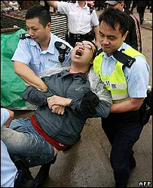
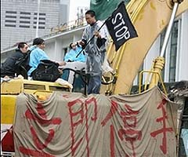
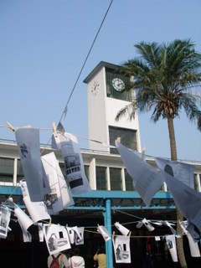
Last Sunday, the election was held for the 800-person committee that is to elect the next Chief Executive. There are about 240 000 eligible voters (I might have been eligible if I were still at CUHK). The turnout was 27%, which was higher than for the previous election. The main interest however, was that a representative from the pan-democrat camp has decided to compete in the CE election next year. But to do that, he has to be nominated by at least 100 of the 800-person committee. This is now possible as about 120 ‘democrats’ were elected and most of them are expected to nominate and then later vote for him. However, the majority of the 800 members will still nominate/vote for Beijing’s choice, which is certain to be Donald Tsang. But at least a competition, will force Beijing’s person to discuss issues and have some sort of platform.

There have been protests at the old Star Ferry pier on HK side due to the demolition of the clock tower. These were quite violent at times. The protests only ended yesterday when the clock tower eventually came down. The government was surprised at the violent reaction but it shouldn’t have been as it has a report from a few years ago saying that there was likely to be public discontent. ‘Mysteriously’ though this was the only report about the re-development of Central that was not released to the public!! Governments do seem to have ways of keeping secret reports it would rather not divulge to the public. Anyway, the government announced that the clock would be set up somewhere.
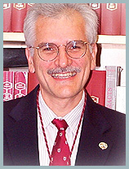
For gym this past week, for one session, I combined weights with 15-min rowing.

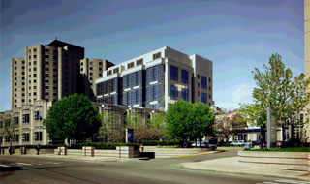
I cut out an article for the SCMP about a report produced by Brigham and Women's Hospital about exhausted interns making mistakes that sometimes kill patients after many hours of continuous work. The interns were 4.1 times more likely to make fatigue-related medical errors that resulted in a patient’s death after working five or more of these long shifts per month than in a comparable month when they did not work such long hours. The study was led by a Charles Czeisler, Division of sleep medicine at B & W and also Harvard Medical School – heard of him, Leonie?
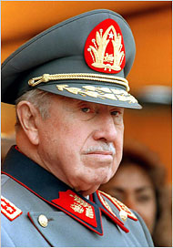
Last Monday, in Chile, the former ‘rightist’ military dictator Augusto Pinochet died. He came to power with the help of the US in 1974 when he overthrew and assassinated the elected but ‘leftist’ president. During Pinochet’s time, many people ‘disappeared’ during his time, which is one reason why there is a lot of hatred towards the man.
That’s about it for now.

Cheers

